Breakdown of Fractions Topic
- Prior Knowledge: Multiples, LCM, Factors, HCF, Prime numbers
- Lesson 1: The relationship between fractions and division. [Dividend, divisor and quotient; similarities and differences]
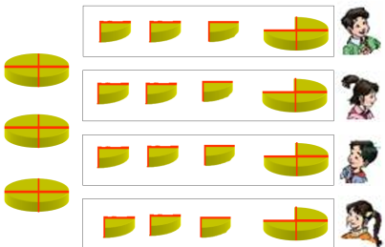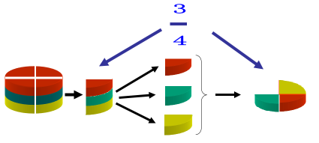
- Lesson 2: The basic property of fractions. [A fraction will retain its value when the numerator and denominator are multiplied or divided by the same non-zero number; equivalent fractions]
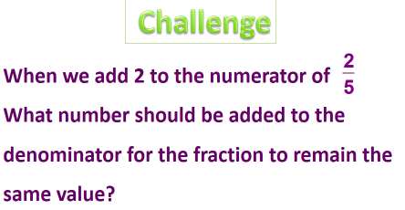
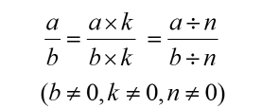
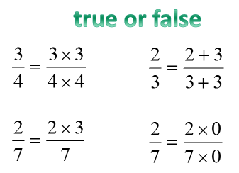
- Lesson 3: Simplifying fractions. [Use of co-prime, simplest fraction]
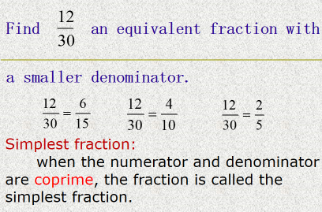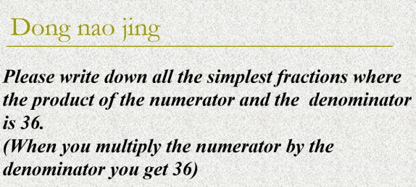
- Lesson 4: Comparing fractions. [Variety of methods including reduction to common denominator]
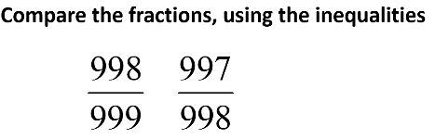
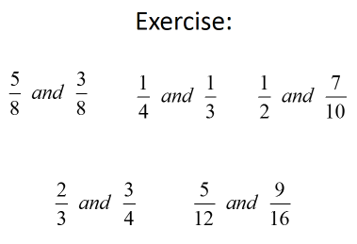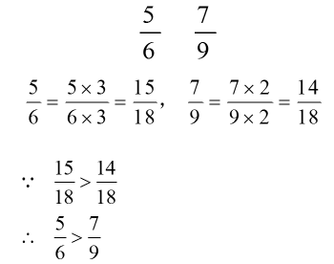
- Lesson 5: Addition and subtraction of fractions with different denominators.
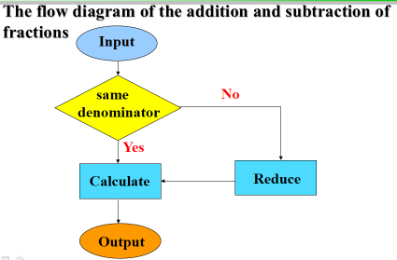
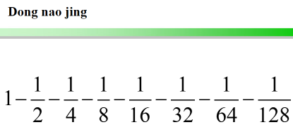
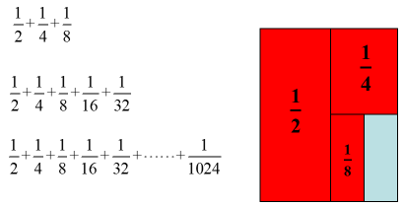

- Lesson 6: Proper fractions, improper fractions and mixed numbers. [Focus on formal definitions; conversion between improper and mixed numbers]
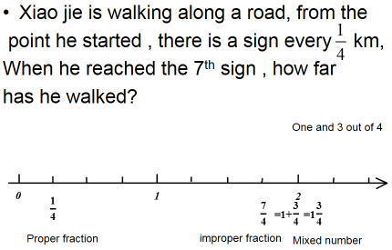
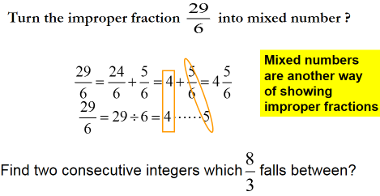
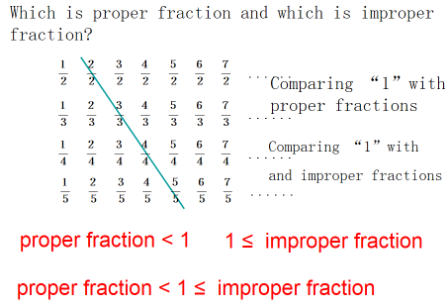
- Lesson 7: Addition and subtraction of mixed numbers. [Multiple methods]
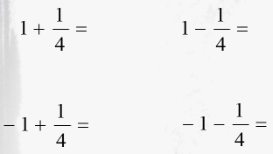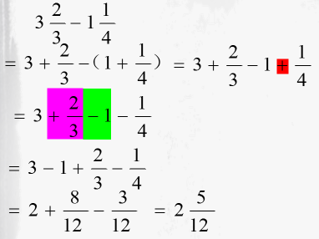
- Lesson 8: Multiplication of fractions. [Using grids, cross cancelling, consider effects of multiplying by proper and improper fractions]
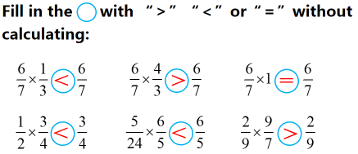
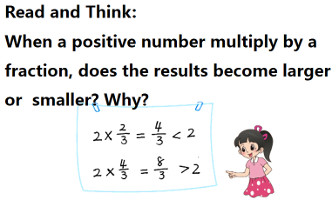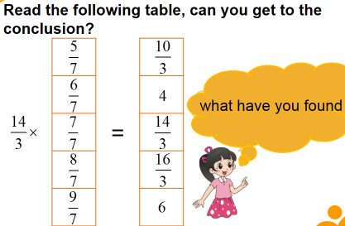
- Lesson 9: Reciprocal. [Link to multiplication, formal definition]
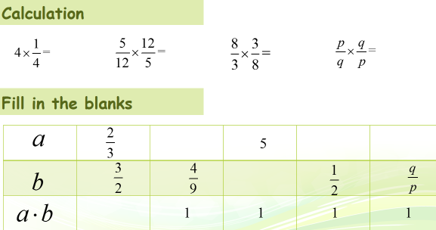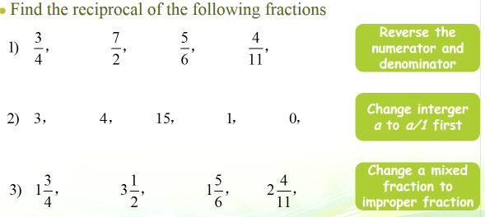
- Lesson 10: Division of fractions – 25th November
Following lessons:
In Shanghai this topic normally takes 20 lessons!

- Mixed operations of fractions
- Convert between fractions and decimals
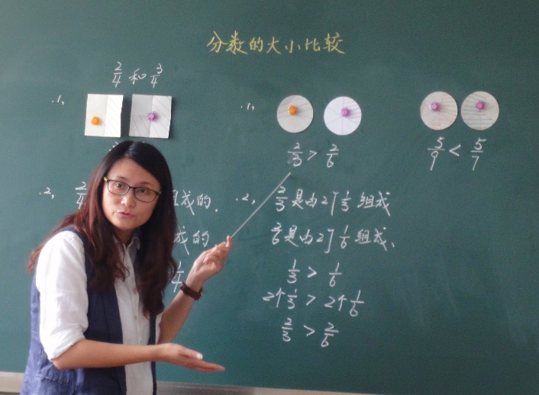
- Recurring decimals to fractions

